Website Brief
Date:
Your Name:
Your Company:
Melbourne IT Consultant:
To ensure that the quote we provide addresses all of your website requirements, please answer the following questions in detail.

About Your Business or Organisation

- What does your business or organisation do?

- What is the purpose of your website?

- Who are your customers? What is your target market?

- Do you have a website already? What is the website address?

Yes, my website address is ……

(If ‘No’, please go to Question 7.)

- Which features/functions of your current website would you like to keep?

- What changes would you like to make to your current website?

- What would you like your customers to be able to do through your website?

- What other features would you like your website to have? Please give details.

Reference Websites

- Please give examples of websites that you like.

Similar businesses | Functionality | Design
www. | www. | www.
www. | www. | www.
www. | www. | www.
www. | www. | www.
www. | www. | www.

- What do you like about the websites you listed above? Which features would you like to include in your website?

E-commerce

- Are you a retailer or are you a wholesaler?

- Will you be selling your products or services online?

(If ‘No’, please go to Question 16, Design.)

- What products or services will you be selling?

- How many products will you be selling?

Example: Bookstore with 700 titles for sale = 700 products

- Please list your product categories and sub-categories.

Example of Categories: Fiction, Non-Fiction, Children’s Books
Example of Sub-Categories: Picture Books, Food, Gardening, Travel, Health, Biography, Sport, History, Science, Photography, Art, Music, Film, Gift

Design

- Would you like your site to be custom-designed (i.e. to have the graphic design and navigation of the site tailored to your specifications)? Please comment on your requirements.

- Do you have company branding?

- Do you have a company logo?

Website Administration

- Do you need to give different people or different groups the ability to update and edit different sections of the website? (E.g. Only Finance department can edit the finance pages.)

(If ‘No’, please go to Question 20, Controlling Access)

    - How many people or groups will be administering the website?

    - Please give details of the different tasks administrators will perform. (E.g. Publicity staff will update Events section.)

Controlling Access to Your Web Pages

- Will all of your web pages be open to the public?

(If ‘Yes’, please go to Question 21, Website Structure)

If you need to control access to your web pages:
- What kind of information will people be accessing? (E.g. MS Word documents of company policies)

- How many protected sections will there be?

- How many people will be accessing the protected sections?

- How many passwords will you need? (One password per person? The same password for everyone?)

Website Structure

- What information will be included in your website?

- If possible, please forward a map of your website, or make a list of your web pages. Here are two examples.

Example A – map of an 8-page website
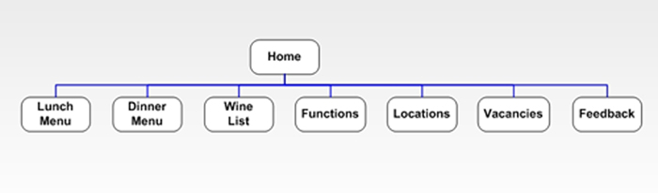
Example B – list of web pages for an e-commerce site
- Home
- Products – catalogue of 500 products with shopping cart
- Delivery
- Returns Policy
- Testimonials
- About Us
- Contact Us

Deadline and Budget

- What is your deadline for having the website live on the Internet? If the website has to be completed in time for an event (e.g. an advertising campaign), please give details and dates.

- What is your budget for the website?

